**INTRODUCTION**

**Overview**: Salesforce

Salesforce, Inc. is an American cloud-based software company headquartered in San Francisco, California. It provides customer relationship management (CRM) software and applications focused on sales, customer service, marketing automation, e-commerce, analytics, and application development. Founded by former Oracle executive Marc Benioff, Salesforce quickly grew into one of the largest companies in the world, making its IPO in 2004. Salesforce's continued growth makes it the first cloud computing company to reach US$1 billion in annual revenue by fiscal year 2009,and the world's largest enterprise software firm by 2022. Salesforce was 0 executive Marc Benioff, together with Parker Harris, Dave Moellenhoff, and Frank Dominguez as a software as a service (SaaS) company. Two of Salesforce's earliest investors were Larry Ellison, the co-founder and first CEO of Oracle, and Halsey Minor, the founder of CNET.

## Salesforce Services:

Salesforce offers several customer relationship management (CRM) services, including Sales Cloud, Service Cloud, Marketing Cloud, and Commerce Cloud and Platform. Additional technologies include Slack.

**Main services**:

Salesforce's main services are for customer management. Other services include app creation, data integration and visualization, and training…

**Salesforce Platform**:

Salesforce Platform (formerly known as Force.com) is a platform as a service (PaaS) that allows developers to add applications to the main Salesforce.com application. These applications are hosted on Salesforce.com's infrastructure. Force.com applications are built using Apex, a proprietary Java-like programming language to generate HTML originally via the "Visualforce" framework. Beginning in 2015 the "Lightning Components" framework has been supported. As of 2014, the Force.com platform had 1.5 million registered developers according to SalesForce.

**Trailhead**:

Launched in 2014, Trailhead is a free online learning platform with courses focused on Salesforce technologies.

**AppExchange**:

Launched in 2005, the Salesforce AppExchange is an online app store that allows users to sell third-party applications and consulting services.

**Overview**: School Management Project

A school management system is an information management system for educational institutions to manage student data. It helps teachers get information about students faster, easier and reduces their workload. Student databases in school management systems contain information about the students, such as their exam grades, parent information, medical history, tuition fees, etc. School management systems provide skills such as student registration, class documents, grades, analytical grades for students, and other assessment elements. In addition, school management systems are used to plan the curriculum of students, record their presence and manage the needs of students in the school. School management solutions are web and mobile-based applications with centralized data storage structures that make it easier for administrators, students, teachers, and parents to access data from iPhone and Android devices.

There are various software tools you can use to automate your organization to achieve your goals and take advantage of digitalization in operation, and school management software is an integral part of every school or college. The school management software consists of several modules that manage the entire school life cycle that includes:

* Student enrollment.
* School activities.
* Fees collection.
* Student’s reports.
* Transportation.
* Libraries

In our School Management Project, first our team members will be created three different objects called School, Student and Parent for web interface for everyone who accessed the School Management Service in the site. Second our team members will be created School fields, Student Fields and Parent fields to be filled information in future. Next, our team members will be created school profile (e.g standard user). Next, we should create three users such as parent, teacher and principal. Next, we will be created permission sets such as read, edit, created for principal, Parent, school, student objects. Next, we will add data to student object. Finally, we will created, saved, viewed and deleted various reports.

**PURPOSE**

Education is the backbone of human society. So, it is important to provide elegant, strong, and quality education to every youth of the generation to make sure that their personality is developed in a better way.

**Automation** – The automation feature of this management system will mitigate the task of writing the papers. E.g., there is no need to write the report card of the students on paper with a pen. It is simply can be done online on the system, and can be forwarded to the students and their parents.

**Easy Interaction** – In today’s rush hour of life, it is difficult for a parent to go to the school of his / her child every time a teacher call. With this management system, it will easier for a parent and a teacher to be in touch every day. As a matter of fact, it will be easier for each individual person who is associated with the system to be in touch as needed.

So far getting my point? I hope so. If not, I will list some key features of this school management system that may help you to get some points.

**Admin**

Admin is the one who controls the whole school management system, its staff, and every other person or thing that is associated with the school. In other term, the admin is the most powerful entity of the system.

**Registration**:

To start with the school, students, teachers, peons, librarians will have to register themselves. For registration, some personal details will be asked on the portal. Name – Each user will have to provide his/her full name. Password – The user will have to enter the password of his / her choice so that he/she easily remembers. The password will be used to authenticate the user to avoid irrelevant hooligans. Email ID – The email id is also a necessary field. The email id can be used to recover the password and all the important information regarding the academics can be mail to the recipient. Contact No.

**Edit Profile**:

The user will have to enter some additional information to use the system efficiently. Following are some fields each user has to enter after login into the system: Gender, Age, Date of Birth, Home Address, Work Address (for parents), Emergency Contact Name, Emergency Contact Number, Alternative Email ID (if any), Designation (for parents),

**Teacher**: The teacher is one of the important entities for a school. The teachers are there to teach the students. The following are the features that will be available to the teachers.

Mark the Attendance: The teacher can take the attendance of the students. He/she just has to enter the class and section name into the portal and the whole list of the registered students of the section will be displayed to him/her. The teacher can mark the present and absent accordingly and at last, can save the record. This data will be reflected immediately.

**View Student Profile** – The teacher can be able to access any student’s profile and acquire the information related to it. View Student’s Marks – It is also another add-on in a teacher’s account. He/she can view the performance of the student in class components, mid-term or end-term examination. Thus he/she can give guidance to the weak students accordingly.

**Student**: The student is also one of the main parts of the system. The students can log in to the student account anytime they want.

**LITERATURE SURVEY**

**Existing problem**: There are no such disadvantages of school management software but there are some issues that are commonly faced by users. The software is not user-friendly – it can be difficult for teachers and administrators to use if the software is not well designed with the latest UI parameters. If the school management software is not affordable, then it can be a financial burden for schools. The school management software does not have enough features to fulfill the school’s requirements. These are a few issues or demerits that users generally face, but that doesn’t mean you back off using such software. They are resolvable issues and many new platforms in the school management industry are already gotten over these issues. **User-Interface**: Complex-user interface may lead to increased difficulty in acceptance of the student management software among the school staff. Being humans, it is natural that the school staff, parents and students may have difficulty using it initially till they get a hang of it. An easy-to-use interface not only increases the acceptance level of the software but also saves time and money spent on training the stakeholders to use the system.

Absence of good internet facility: Good internet connectivity is another major issue that needs to be addressed. It is not actually a disadvantages of student management system but instead is necessary for its optimal functioning.

**User requirements**: Whether the software will satisfy your expectations will depend on how useful it is in reducing the efforts of the teachers, parents, students, etc. And after implementation, if it fails to meet the requirements, then it would result in wastage of money, time, and effort. In such a case, it is best to opt for solutions that come with a free plan and can be upgraded whenever you want. This offers you a possibility to try and test whether it is beneficial for your school and its stakeholders. The student result management system is prone to hacks. Administration cannot edit or modify scores after the deadline. Extensive modules and features make it difficult for a user to utilize the application. Minor technical glitches and issues.

**Existing approaches or method to solve this problem**:

Get to know why School Management Software has become a need for modern institutions with this list of the top best school management systems. Schools are everywhere, be it a rural area or an urban area, be it any part of the world. With the emergence of the pandemic in 2020, schools from all over the world had no other option but to close their premises. No one could go out, even for receiving an education. In that situation, people started thinking of ways to conduct classes online and administer the schools remotely. Some schools were already using the platforms for school management that helped them in continuing the functioning of schools. School management system is the modern solution that aid schools, students, and parents in many ways. The benefits of school management systems are as follows: You can conduct online classes, examinations, quizzes, meetings, etc. Parents can pay the fees online, anytime, from anywhere, thus saving much of their time that would have been spent just standing in a long queue for hours. Students, parents, and teachers will receive notifications about due dates for assignments and other alerts for upcoming events. Parents can communicate with the school staff easily. The location of school vehicles can be tracked. Report cards, ID cards, and other certificates can be made, shared, and stored online. Mobile applications or sites are available to access all the features, anytime, from anywhere.

Some popularly known school management systems: Gradelink, MyClassCampus, PowerSchool SIS, Vidyalaya, Alma, Rediker, Your Agora, Schoolbic, FamilyID, Ireava, Eduwonka, FreshSchools, EDRP, OpenEduCat, Fedena.

**PROPOSED SOLUTION**:

As businesses strive to enhance their customer relationships and streamline their operations, Salesforce has emerged as an agile system that delivers results. With its comprehensive CRM platform, Salesforce empowers organizations to effectively manage sales processes, marketing campaigns, and customer interactions. The advantages of Salesforce extend beyond its robust features and **cloud-based** **architecture**. From scalability and automation to real-time analytics and seamless integrations, Salesforce is a preferred choice for businesses of all sizes.

Salesforce benefits include:

Comprehensive CRM: Salesforce offers a complete customer relationship management platform to track interactions, sales, and marketing.

Scalable and Flexible: Salesforce adapts to businesses of all sizes and can be customized to specific needs.

Cloud-based: Accessible from anywhere, with automatic updates and high security standards.

Extensive AppExchange: The platform provides a marketplace with pre-built apps, integrations, and industry-specific solutions.

Automation and Workflow: Your team can automate tasks, standardize processes, and boost efficiency.

Real-time Analytics: Gain insights into sales, marketing, and customer behavior instantly.

Mobile Accessibility: Manage customer interactions and collaborate on iOS and Android devices.

Integration Capabilities: Seamlessly connect Salesforce with other business systems for data synchronization.

Community and Collaboration: Foster collaboration, knowledge sharing, and self-service capabilities.

Ongoing Innovation and Support: Regular releases, training resources, and a supportive user community let you leverage Salesforce with confidence and ease.

**BLOCK DIAGRAM**

**DIAGRAMMATIC OVERVIEW OF THE PROJECT**

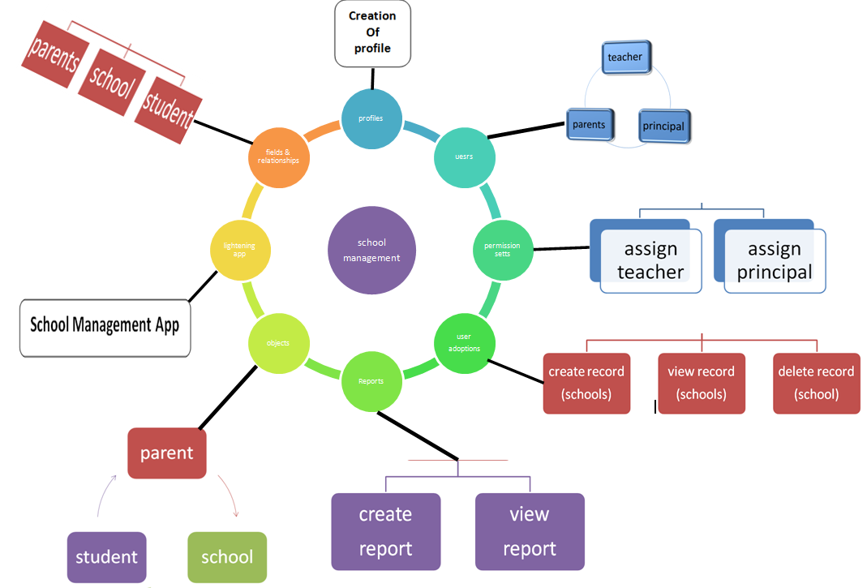

.

HARDWARE / SOFTWARE DESIGNING:

**Hardware requirements of the project**:

**Memory (RAM)**

* 8 GB RAM
* 16 GB RAM if the access node also hosts the database

**Processor**

* Minimum of 8 CPUs/processors.

**Software requirements of the project**:

**Browsers**

* Google Chrome
* Safari
* Mozilla Firefox
* Microsoft Edge

**Mobile and Desktop Operating Systems**

* Mac: macOS 10.14 (Mojave) or later
* Windows: Windows 7 or later
* iOS: iOS 13 or later
* Android: Android 5.0 (Lollipop) or later

**RESULT**

Final findings (Output) of the project along with screenshots.

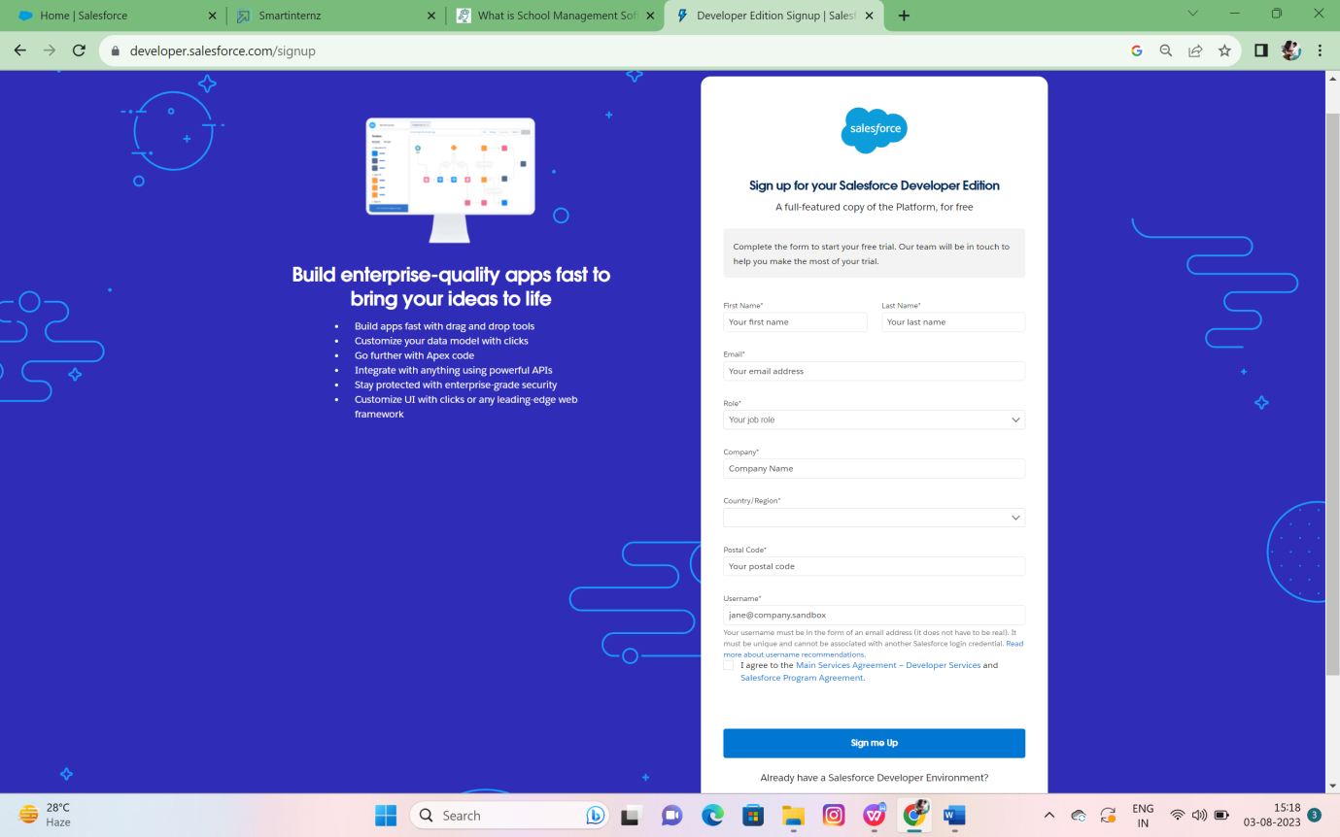

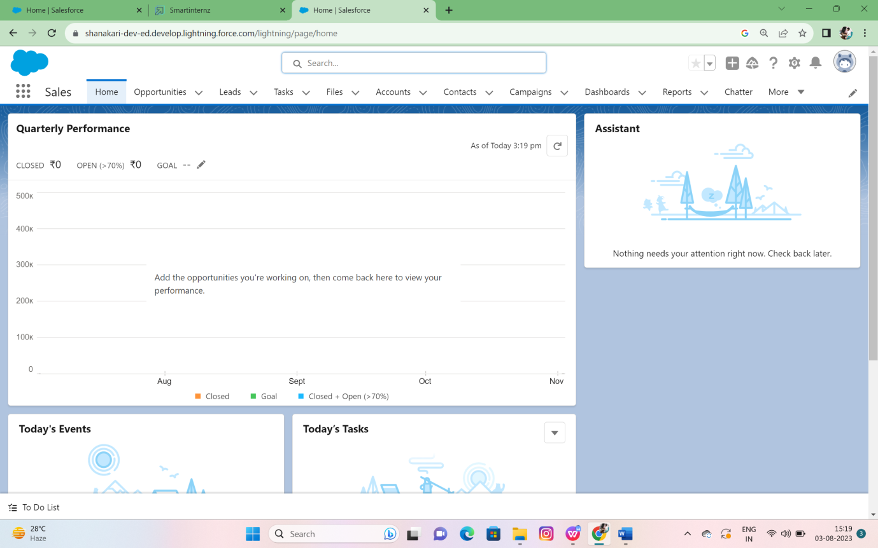

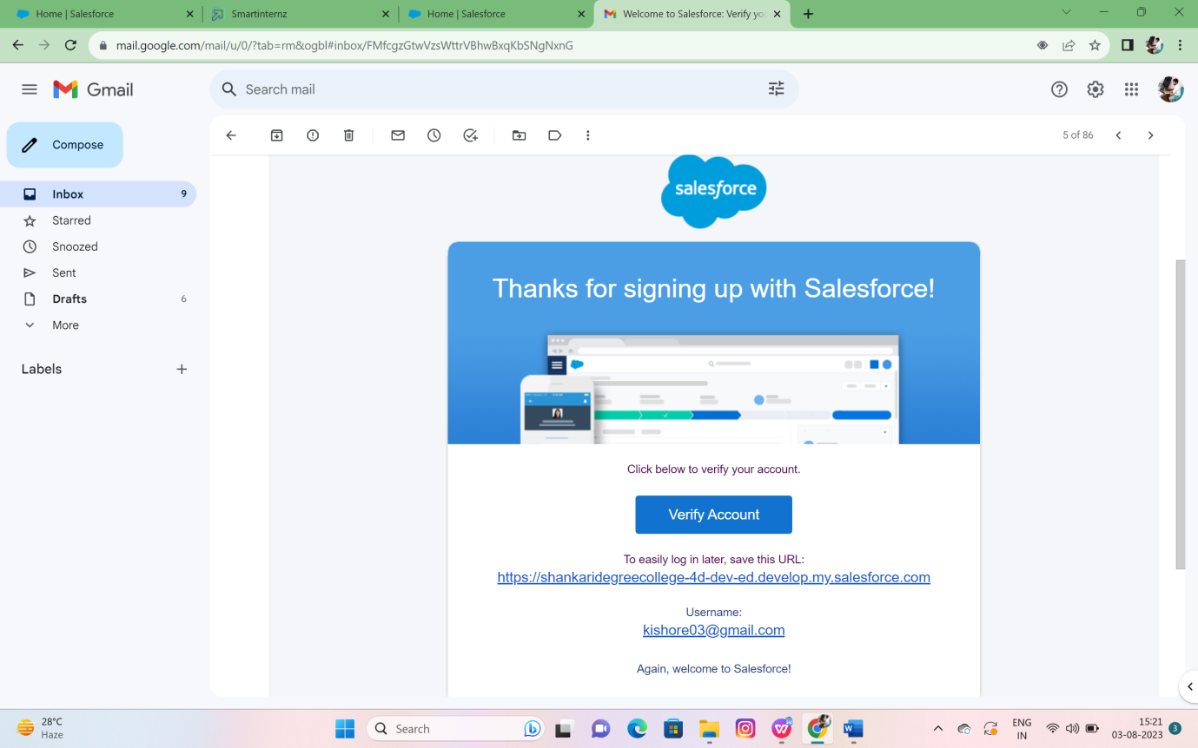

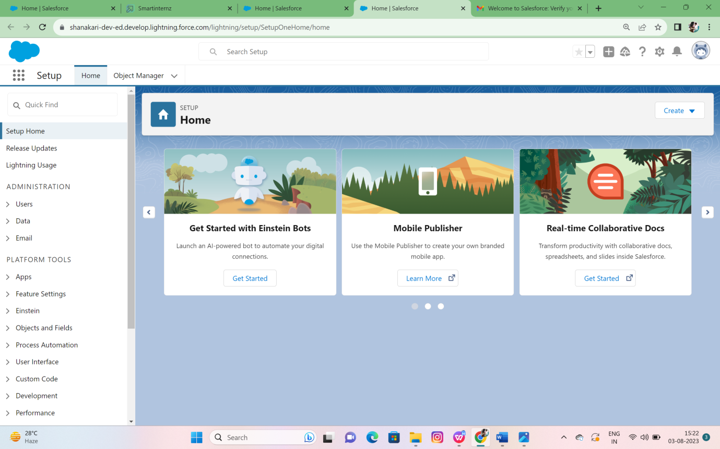

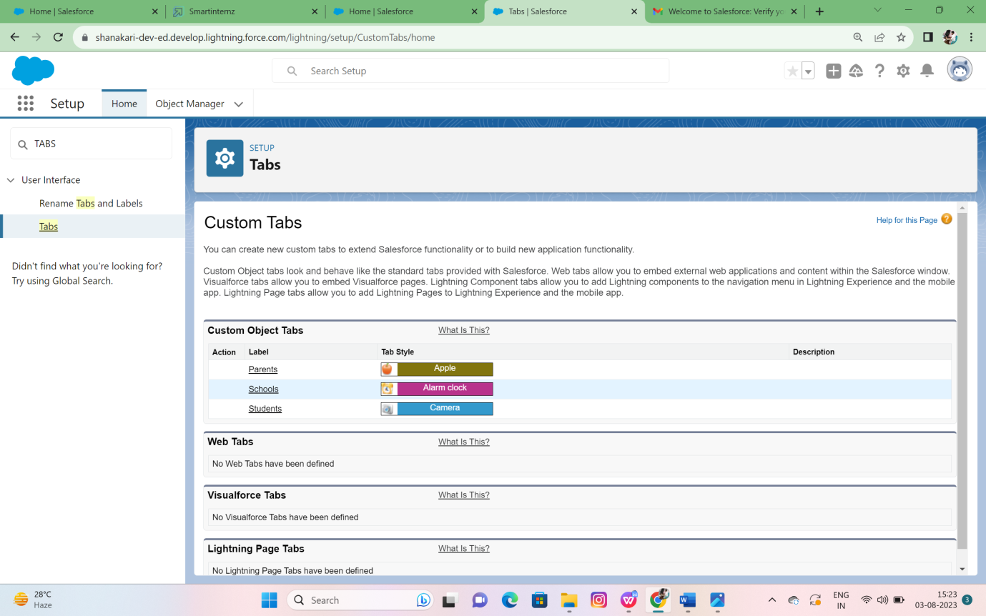

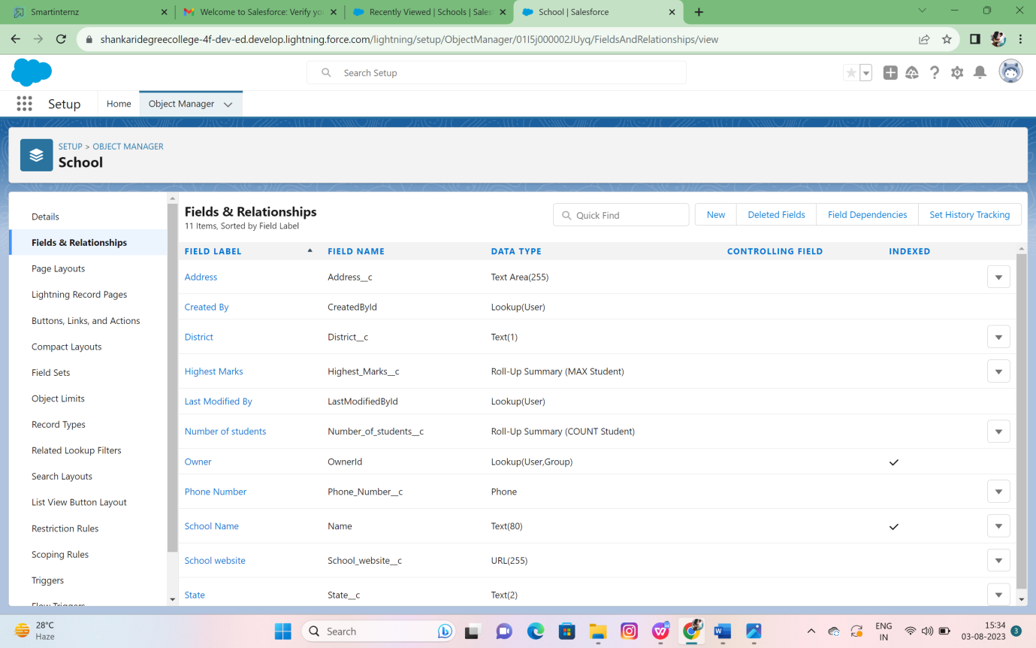 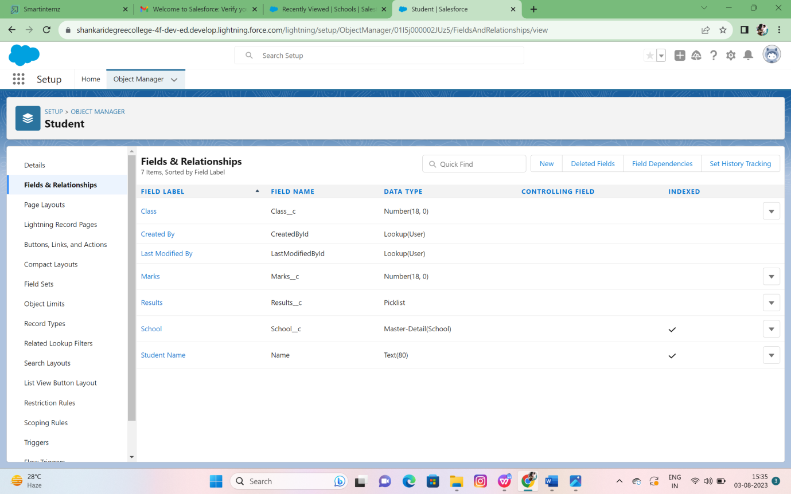

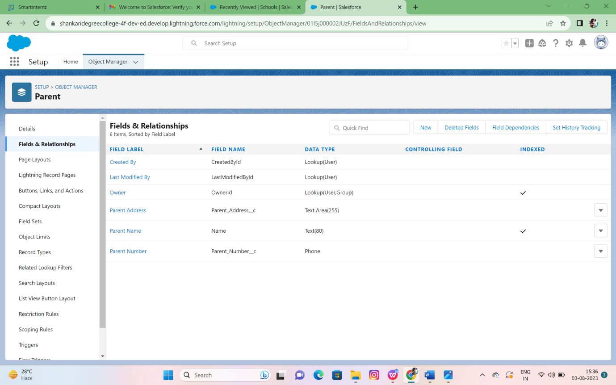

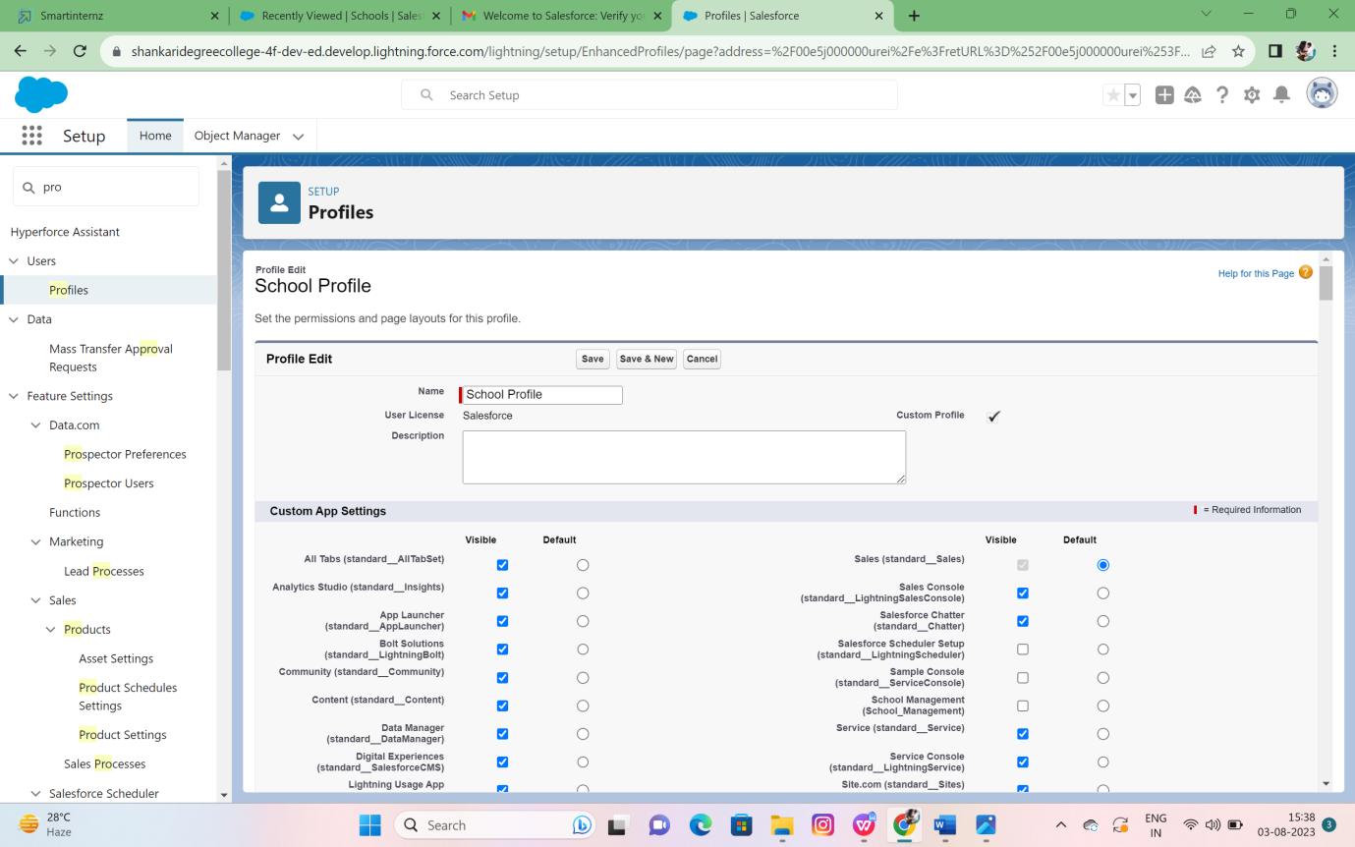

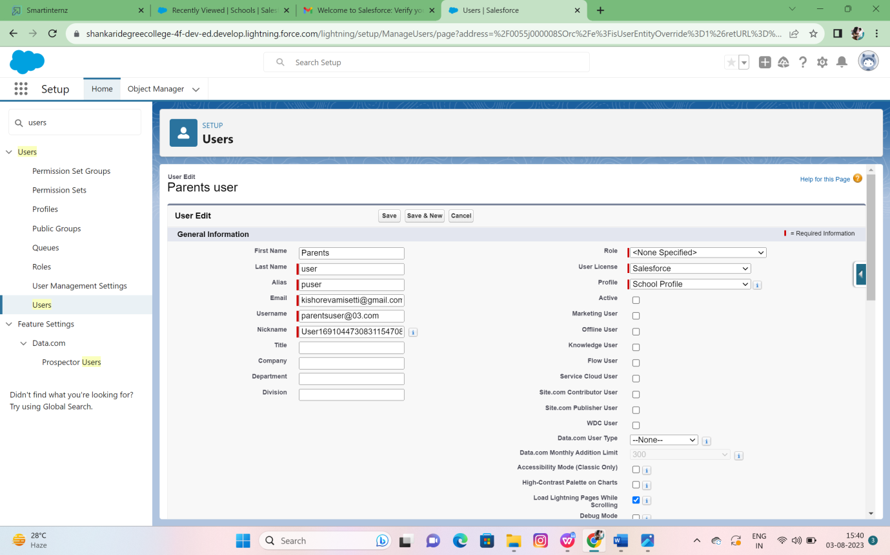

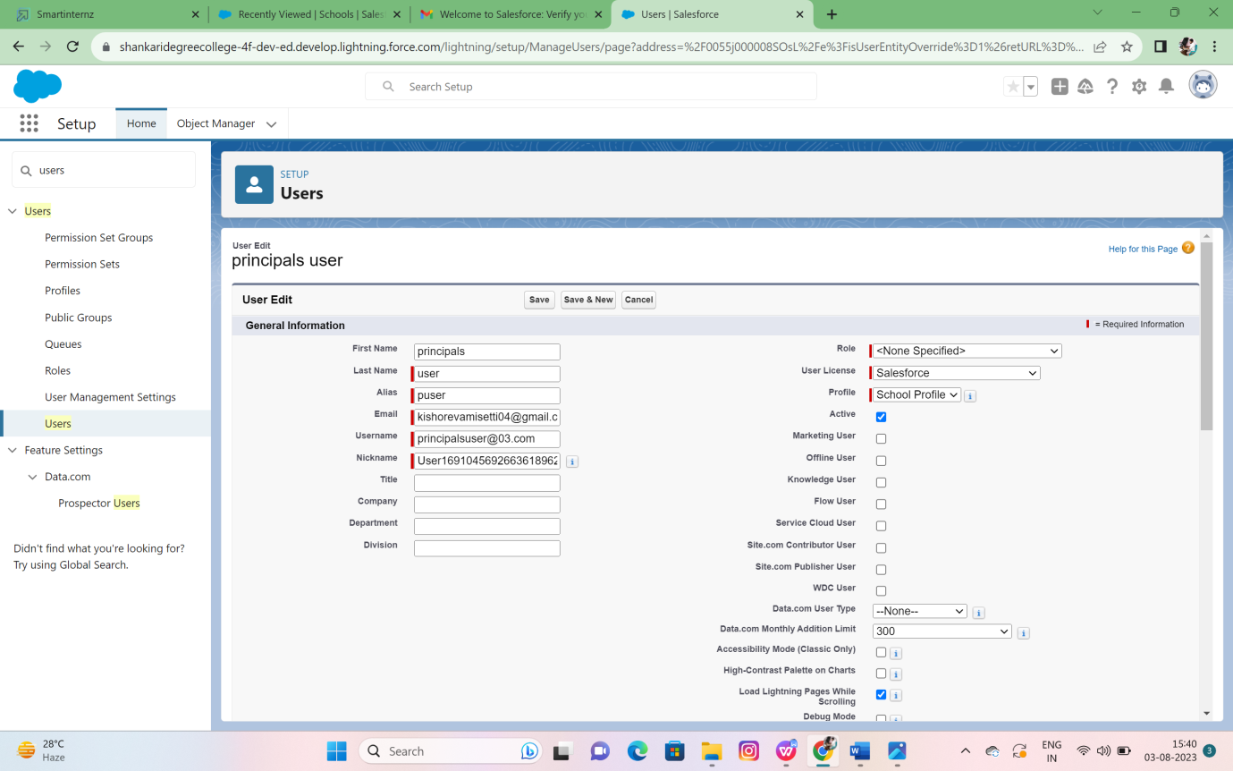

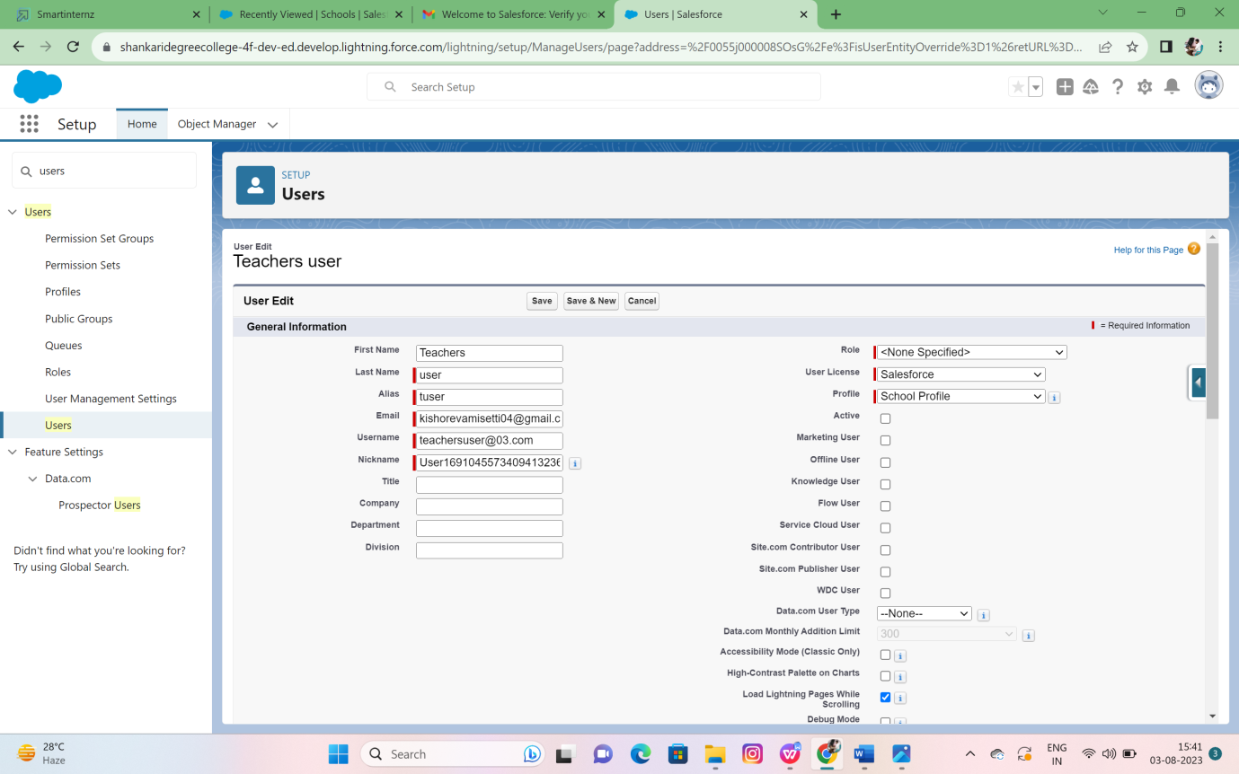

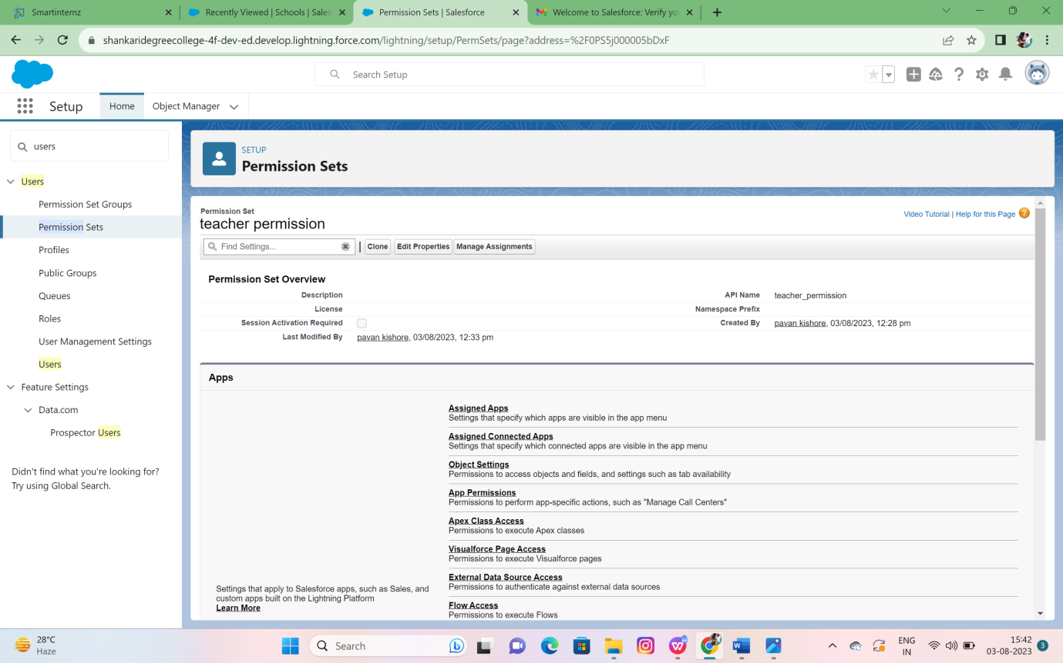

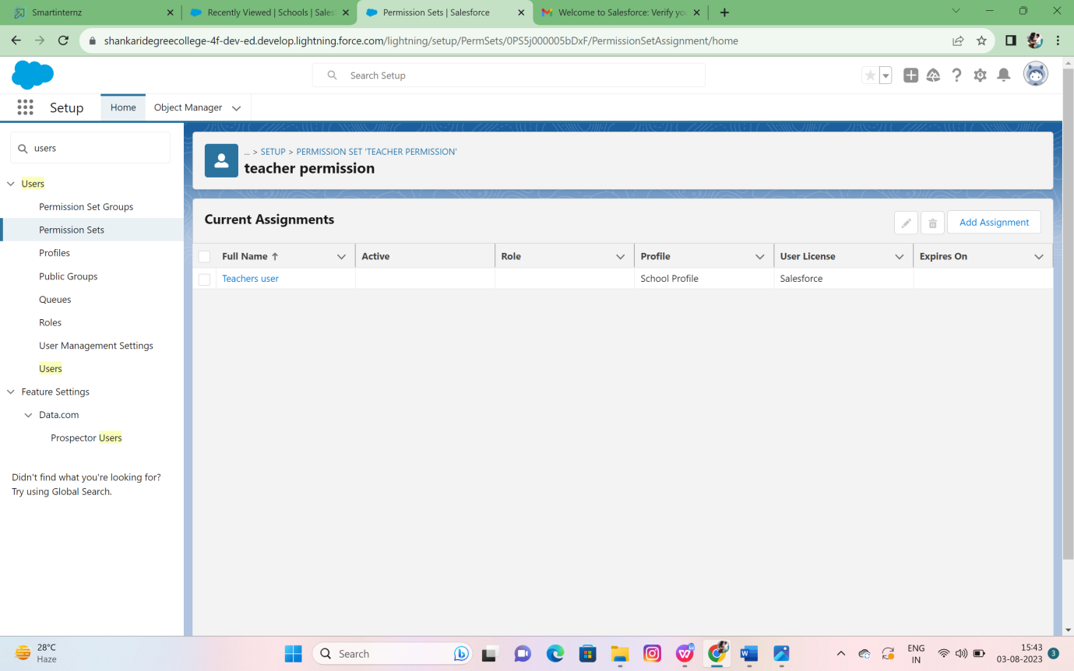

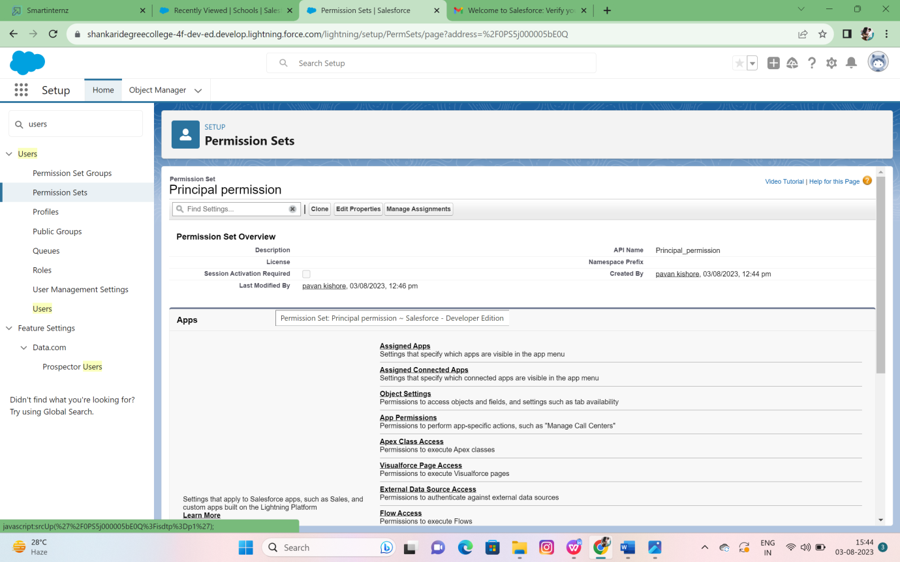

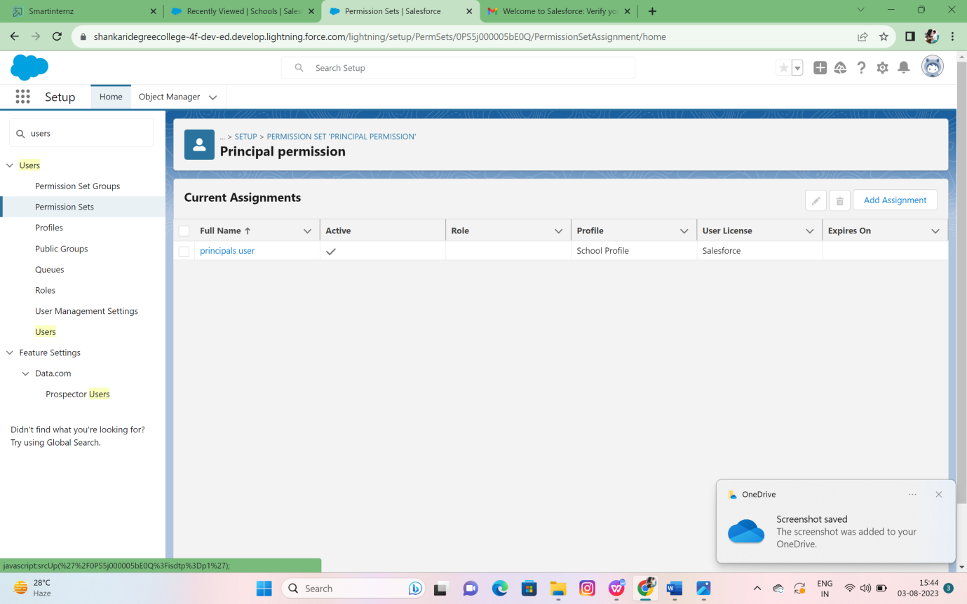

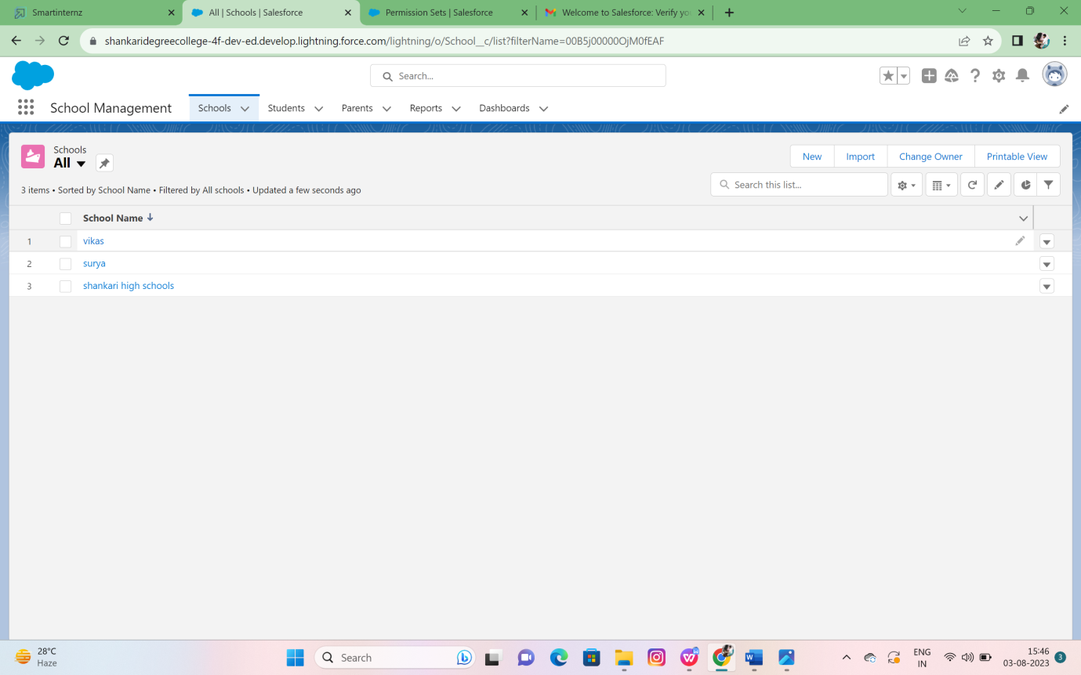

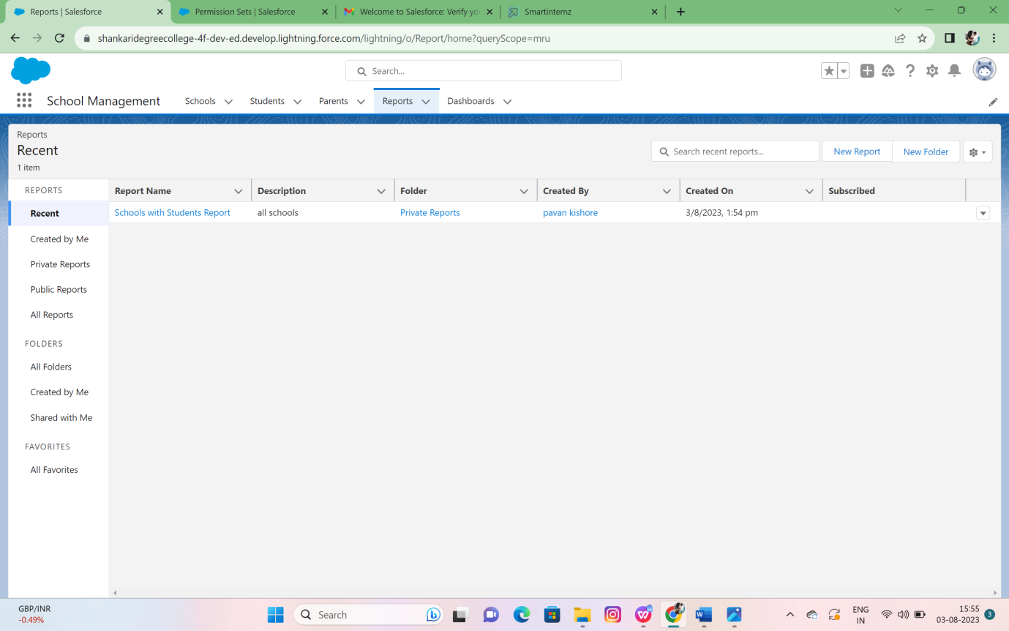

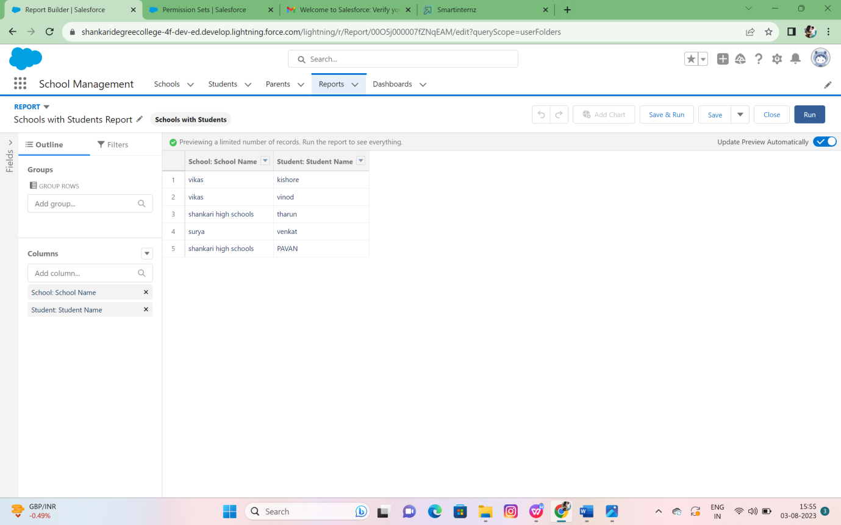

**ADVANTAGES & DISADVANTAGES**

1. Better Time Management

Time management is a huge benefit of Salesforce and one of the best ways to allow a business to grow and thrive. Thanks to comprehensive customer information and useful planning resources, you have everything you need in one place. No more time wasted searching through logs and files for important info.

With so much pertinent customer data, you can easily prioritize work for (and with) your clients by streamlining the sales funnel so that leads are quickly transformed into customers.

Salesforce also has a calendar feature that makes it easy to plan projects, meetings, phone calls, and more in one place. You’ll know what’s coming up and when.

2. Ultimate Accessibility

Since Salesforce is cloud software, it’s accessible anywhere and everywhere you have access to the Internet. Whether you use your desktop, laptop, or smart phone, Salesforce can be reached thanks to its app. This is important because many business owners and team members travel frequently, be it nationally, internationally, or even between cities.

Being able to reach your CRM tool through the protected cloud no matter where you are makes it easier to access important files and stay updated on clients. Sensitive information is more secure than it would be in a file cabinet or on a local server.

3. Increased Revenue

Without Salesforce, running a business in today’s world can cost you money. On any given day, your team might produce a ton of data that has to be stored. Without Salesforce, you’re most likely sorting through this data manually, and this is more time spent on administrative work as opposed to building customer relationships.

When your time is tied up, it means you have less time to improve business, make connections, and grow profits. Since the tool takes over these administrative duties and more, you’ll have more time to devote to the business, which means more money in the long run.

4. Greater Customer Satisfaction

Similar to increased revenue, it’s safe to assume customers are more satisfied when they interact with a business that knows their needs and the state of their relationship with you (thanks to your CRM tool). Spend less time on administrative duties and you’ll have more time to spend catering to your customers through a common platform.

Thanks to a highly efficient management system, you can serve your customers better by having quicker access to their information, accounts, purchase history, and preferences.

This Salesforce benefit not only improves your relationship with your customers – it sets you up for new customers too. When your current customers are happy with you, they’re more likely to be an ambassador for you and tell their friends.

5. Simple Account Planning

Salesforce makes it simple to create plans for accounts. With all the customer information you need readily accessible, you’ll have an easier time placing that info into the correct accounts, and then making plans for those accounts for optimal results for the customer.

Customers get products or services perfectly tailored to their needs, you stay organized, and you adjust your time effectively for each client. As these accounts are created, stronger connections are made with your clients by best meeting their needs, solving their problems, and keeping track of trends.

6. Trusted Reporting

With so much data pouring into your business, it’s easy to become lost. Salesforce keeps pertinent data organized and it helps you make sense of new data thanks to trustworthy reporting.

Keep track of all the data your business collects from social media, website analytics, app information, business software, and more. Reporting takes this mountain of information and sorts it, analyzes it, and makes it actionable. With the accuracy of Salesforce tech, you know the numbers are right and the readings can be trusted.

7. Improved Team Collaboration

Lastly, team collaboration is a major benefit of Salesforce. The software allows you to connect and communicate with team members from anywhere thanks to the “Chatter” feature. This lets you connect with individual team members or full groups and chat about everything from your clients and their information to other work-related topics such as territory and product/service details.

When the team is on the same page, your business is more cohesive and operates more efficiently so that deadlines are met and sales are finalized.

**Salesforce Disadvantages**

Along with its myriad of advantages, Salesforce is not without a few caveats that organizations should consider.

Steep learning curve: Users sometimes find it challenging to quickly grasp all the functionalities of Salesforce. The platform can be complex, and it may require comprehensive training for users to become proficient in navigating and utilizing its features effectively.

Cost implications: Salesforce can be costly, especially for larger organizations or those requiring extensive customization. The pricing structure typically involves per-user monthly fees, which can range from a few tens to hundreds of dollars. Additionally, the costs can increase if you opt for additional features, integrations, or storage space.

Limited mobile app functionality: Some users have reported limitations with the Salesforce mobile app. Certain features and functionalities available on the desktop version may not be fully accessible or optimized for mobile devices.

Data storage limitations: Salesforce imposes data storage limits that organizations may find restrictive, especially if they generate and handle substantial amounts of data. As a result, companies may need to purchase additional storage space.

Dependency on internet connectivity: Salesforce operates primarily as a cloud-based platform, which means users heavily rely on stable internet connectivity. In situations where internet access is limited or unreliable, users may face difficulties.

Customization complexity: While Salesforce offers a robust set of customization options, configuring and tailoring the platform to specific business needs can be complex and require technical expertise. Organizations may need to invest in additional resources, such as Salesforce administrators or consultants.

Integration challenges: Depending on the complexity of the integration requirements, organizations may need to invest significant time and effort to ensure seamless data flow and integration between Salesforce and other systems.

**APPLICATIONS**

Customer Service: Salesforce provides excellent customer service from anywhere in the world. It helps in resolving customer issues faster and improves support agent response time. Salesforce allows you to unify email, social, phone, and chat support and helps manage every channel from one view.

Customize Data: Salesforce allows you to handle and customize different types of data. It helps you track real-time analytics and enhance the customer experience.

Flexible Data Reporting and Analysis: Salesforce allows flexible data reporting and analysis. Here, sales representatives can create their reports to check the accounts they haven’t worked on for a while.

Understand Customer Data: The Salesforce tool makes you understand customer data, identify their interests and perception. You can locate and re-engage inactive customers and increase sales by tracking customer interaction.

Salesforce is used in the following areas…

* Schools
* Colleges
* Universities
* Companies
* Hospitals
* E-commerce organizations

**CONCLUSION**

Salesforce has become synonymous with CRM. Organizations can use Salesforce for contact management, customer engagement, workflow creation, task management, and opportunity tracking. You can also collaborate with colleagues, run analytics, and access Salesforce from a mobile dashboard. Since marketing has become a large part of CRM, Salesforce includes features for things like social media and email campaigns.

In the Salesforce AppExchange, you can get third-party add-ons to extend and customize Salesforce to your company’s needs. These add-ons use API integrations to move data back and forth and CTI integrations to work with your telephone system.

With the knowledge you’ve gained from this guide, you can now start exploring Salesforce as a viable option for CRM. As you continue your Salesforce journey, regularly review the extensions you’ve added to make sure they meet your needs and to ensure you get the most out of your Salesforce clouds.

**FUTURE SCOPE**

The following Enhancements that can be made in the future:

**Student Information**: Teachers can make use of the student database to get basic student information like: Grades, Address, Information regarding family, Attendance, Homework,

Discipline, Achievements, and so on. Almost all the information with respect to the students can be accessed easily using efficient school management software. In addition, details pertaining to the medical history, accounts, billing, etc. of the students can also be added by the administration. If student ID cards are turned into smart cards, access to details pertaining to a particular student becomes simpler than ever before.

**Teacher Information**: Having a rich database of students is not enough - there should be an equally accessible and robust database dedicated to teachers as well. It must be easy to view a particular teacher’s class schedule, file reports efficiently, etc., and use their database to keep the details regarding class timings, student progress, and classroom activities in one place. Some of the advantages of having such a system include: Teachers can log onto their database to access their records related to school, classroom, and/or student activities Classroom reports and forms can be filled with relative ease using the school management software where almost all the information regarding the class can be duly updated Teachers can notify parents quite easily about the report of the students once they are filed.

**Attendance Management**: Attendance management is a vital part of classroom administration and it requires teachers to spend a considerable amount of time at the beginning of each class to keep a regular record of all the students who are present or absent in class on that day. Sometimes, it becomes difficult for teachers to manage the whole process of taking attendance and recording them with precision. In addition, manually marking attendance also means that there is room for error on the side of the teacher.

**Online Assignments and Assessments**: Since every aspect of education is increasingly becoming online, it is only logical that assessments and assignments are also evaluated likewise. Teachers can even provide individual customized assignments to each student on the basis of their level of knowledge if they so require.

**Report Card Generation**: A Report Card is a representation of a student’s hard work throughout the course of a year and is the most anticipated report in an academic year in the life of a student. However, the teachers, as well as the school administration, find it to be a time-consuming responsibility, which is where school management systems come in. School management software can help school authorities as well as teachers to streamline the process of generating report cards by means of an interactive database. Using the available information about the performance of the class, attendance, and results of the students, the database completes the report card automatically. Teachers can review the same before finalizing the report and approve the report card, after which it is made accessible to parents and students with immediate effect.

**Fee Management System**: This is another paramount feature of a school management system. Fee management is one of the most vital components of the smooth operation of a school system, and any hindrances that come in its way can have a serious negative impact on a school’s financial strength. Managing receipts and due payments, tracking several types of fees before applying them to the right student, preparing bills, etc can be a time-consuming process and difficult without the proper software to handle these different functions which are quite often required to be done simultaneously. This is where a robust fee management system is required.

**Admission Management**: Admission management is another area where school management systems can bring about a revolution. Hoarding bundles of files can now be conveniently replaced by putting all that data into a system. This method can help the administration access the data instantly whenever required. Such software is capable enough to manage the registration and admission process of both old and new students smoothly. This software can remove the possible difficulties that can be caused by human errors and treats the new and old students differently on the basis of the information provided.

**Transport Management**: Keeping track of the transport system associated with a school is of prime importance for ensuring student safety and security at all times. With a proper transport management system, schools can keep track of the route taken by each student. An added advantage of such a system is that it also keeps track of students who have opted for school transportation without routes assigned to them. It makes sure that student safety by making sure whether a student is present on the bus or not and later submits the report to their parents.

**School Yearly Calendar Planner**: An academic calendar is one of the basic needs of an effective school management software as it helps all the stakeholders stay updated about the events that are to take place in that academic year. These may include meetings, lectures, exam schedules, assignments, etc. Having a robust school yearly calendar planner makes sure that no stakeholder gets left behind with regard to events that are to take place.

**User-Friendly UI**: For the successful execution of any software, it needs to have an easy-to-use and well-designed user interface (UI). The UI should be designed in such a way that a person with the least computer knowledge should also be able to comprehend it and access the system with a very shallow learning curve. The software must also be customizable as per the requirements of the school.

**Parent Communication**: The parent app gives parents a level of control over their child’s performance at school than ever seen before. It is available in different languages and is quite easy to navigate. The parent app even allows parents to keep track of multiple wards at the same time without even having to change applications.

**Library Management**: Keeping track of which books have been taken by which students were a tedious process, but not anymore. Library management systems are an integral part of school management systems as it reduces the job of librarians manifold.